**MSLC Workshop Series**

**Math 1151 – Workshop**

**Sigma Notation and Riemann Sums**

**Sigma Notation:**

Notation and Interpretation of 

* (capital Greek sigma, corresponds to the letter S) indicates that we are to **sum** numbers of the form indicated by the general term
*  is the **general term**, which determines what is being summed, and can be defined however we want but is usually a formula containing the index: 
* *k* is called the **index**; we may use any letter for the index, typically we use i, j, k, l, m, and n as indices
* The index runs through the positive integers, starting with the number below the (in this case 1) and ending with the integer above the (in this case *n*)
* The sum on the right hand side is the **expanded form**. (The  contains all the terms I was too lazy to write.)
* The letter below the sigma is the variable with respect to the sum. All other letters are **constants** with respect to the sum.

Examples:

1.  2.  3. 

Examples:

$$\sum_{k=1}^{200}{k=}$$

$$\sum_{i=1}^{30}{i^{2}}=$$

$$\sum_{j=1}^{900}{1}=$$

Special Sum Formulas

$$\sum_{k=1}^{n}{1}=n$$ $$\sum_{k=1}^{n}{k}=\frac{n\left(n+1\right)}{2}$$ $$\sum_{k=1}^{n}{k^{2}}=\frac{n\left(n+1\right)\left(2n+1\right)}{6}$$ $$\sum_{k=1}^{n}{k^{3}}={\left[\frac{n\left(n+1\right)}{2}\right]}^{2}$$

Properties of Sigma Notation is an **operator** that represents summation, and its properties are similar to the properties of addition (note what properties are **not** mentioned here).

* Multiplication by a common constant (also called a ***scalar*** multiple) 
* Addition or Subtraction (this is also called the ***linearity*** property) 

Example:

$$\sum_{k=1}^{10}{\left(2k^{2}+k+5\right)}=$$

**Riemann Sums:** 

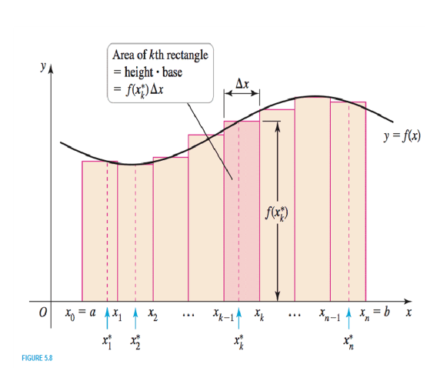

**Definition of a Riemann Sum:**

Consider a function  defined on a closed interval , partitioned into  subintervals of equal width by means of grid points . On each subinterval , pick a sample point . Then the Riemann sum for  corresponding to this partition is given by:



* **WIDTH:** 

Since we partition the interval into evenly spaced partitions, we can calculate the width:

, where *n* is the number of partitions.

* **HEIGHT:** 

Also, we usually don’t pick  arbitrarily. We use a rule to pick . The most common rules to use are the Right Endpoint Rule, the Left Endpoint Rule, and the Midpoint Rule.

The most common rules to use are:

Right Endpoint Rule 

Left Endpoint Rule 

Midpoint Rule 

* If we partition the interval into more and more rectangles with smaller and smaller widths, we get closer to the (signed) area trapped between the curve  and the -axis.

This is where **Sigma Notation** comes in because it becomes time consuming to add up all the terms when there are many, many rectangles.

**Calculating A Riemann Sum**

Using the **Right Endpoint Rule**, the Riemann sum becomes:



Using the **Left Endpoint Rule**, the Riemann sum becomes:



Using the **Midpoint Rule**, the Riemann sum becomes:



**Example:**

Estimate the area under $f(x)=x^{2}+2$ on the interval $[-2, 3]$ using midpoint Riemann Sums and 5 rectangles. No need to use sigma notation here.



**Example:**

Estimate the area under $f(x)=x^{2}+2$ on the interval [-2, 3] using right Riemann Sums and 5 rectangles. Think about how you would write the sum using sigma notation.



**Left Sum:** Estimate the area under $f(x)=x^{2}+2$ on the interval [-2, 3] using left Riemann Sums and 5 rectangles.



**Example:** Estimate the area under $f\left(x\right)=x^{3}$ on the interval [0, 2] using **right Riemann sums** and 10 rectangles. Try using sigma notation!

First calculate the width: 

Then the x-value for the right endpoint of the *k*th rectangle is $x_{k}^{*}=$

Thus the height of the *k*th rectangle is $f\left(x_{k}^{*}\right)=$

So the Riemann sum is

Now evaluate this sum using your knowledge of sigma notation!

**Example:** Estimate the area under $f\left(x\right)=x^{3}$ on the interval [0, 2] using **right Riemann sums** and 50 rectangles. Try to use your work from the previous problem. **What changes?**

First calculate the width: $Δx=$

Then the x-value for the right endpoint of the *k*th rectangle is $x_{k}^{*}=$

Thus the height of the *k*th rectangle is $f\left(x_{k}^{*}\right)=$

So the Riemann sum is

Now evaluate this sum using your knowledge of sigma notation!

**Being More Accurate:**

What if we want to get a better approximation than any of the above give us? More rectangles will give us less extra or unused area between the curve and the -axis. Let’s again do a **right sum** for $f\left(x\right)=x^{3}$ on the interval $\left[0,2\right]$:

$$\sum_{k=1}^{n}{f\left(x_{k}^{*}\right)Δx}$$

using $n$ equal subintervals.

First calculate the width: 

Then the x-value for the right endpoint of the *k*th rectangle is $x_{k}^{*}=$

Thus the height of the *k*th rectangle is $f\left(x_{k}^{*}\right)=$

So the Riemann sum is

Now evaluate this sum using your knowledge of sigma notation!

If you have time, take the limit as $n$ goes to infinity! This is the definite integral $\int_{0}^{2}{x^{3}dx}$.

Note that the definite integral can often be calculated as an area using geometry or with the fundamental theorem of calculus! Don’t do more work than you have to!