**MSLC Workshop Series  
Math 1151 – Workshop 1  
Limits and Continuity**

Warm-up 1: Let $f\left(x\right)=\frac{x^{2}-6x+8}{x-2}$ and let $g\left(x\right)=x-4$. Are *f* and *g* equivalent functions? Why or why not? Hint: Try factoring the numerator of $f(x)$.

Draw the graphs of  and .

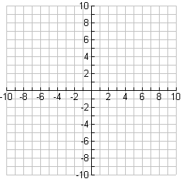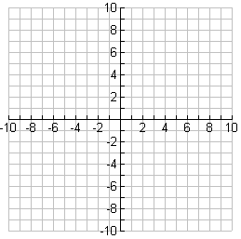

**Limits:**

There is a technical definition, but for us, the intuitive definition will do just fine. Here it is:

The limit $L$ is the value the function “gets close to” if we make the *x* values “get close to” (but not equal to) $a$*.* We write $\lim_{x →a}{f\left(x\right)=L}$.

**Continuity:**

**Definition:** A function $f\left(x\right)$ is continuous at $x=a$ if and only if $\underset{x→a}{lim⁡}f\left(x\right)=f\left(a\right)$.

This definition actually states three things:

1.

2.

3.

**Limits Continuity:**

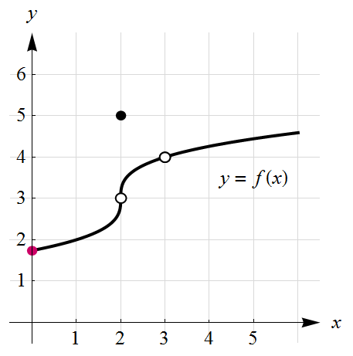

*Part 1: Limits and Continuity given by a Graph*

Let be given by the graph below. Use the graph to find the following.

1. a.  2. a. 

b.  b. 

c. Is  continuous at ? c. 

d. $\lim_{x→1}{(f\left(x\right)+3x)}=$ d. Is  continuous at ?

3. a.  4. a. 

b.  b. 

c.  c. 

d.  d. 

e. Is  continuous at ? e. Is  continuous at ?

f. f.

5. a. 

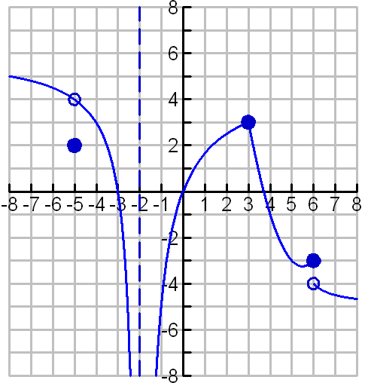

b. 

c. 

d. 

e. Is  continuous at ?

f. 

g. 

*Part 2: Limits and Continuity given by an Equation*

**Hints about finding Limits:**

* Plugging in nearby numbers will get you no credit unless the directions specifically say to do so.
* For any function which is CONTINUOUS, you can find the limit just by plugging in the number as long as the answer is defined.
  + In particular we know the following functions and all their combinations are continuous wherever they are defined:

____________________________ ____________________________

____________________________ ____________________________

____________________________ ____________________________

____________________________

* Ways you can combine continuous functions to get another continuous function:

____________________________ ____________________________

____________________________ ____________________________

____________________________ ____________________________

* What do you do if the function is undefined? Look at the form of the limit!

  

 

Limits Problems:

1. 
2. 
3. 
4. 
5. 
6. List the asymptotes of $f$. Justify your answers by citing appropriate limits. Explain how you know there are no others.
7. 
8. 
9. 
10. 
11. 
12. 
13. 
14. 
15. 
16. 
17. List the asymptotes of $f$. Justify your answers by citing appropriate limits. Explain how you know there are no others.
18. 
19. 
20. 
21. 
22. 

|  |  |  |
| --- | --- | --- |
|  | **Limits** | **Continuity** |
| **Conceptually** | Where is the function headed (y-value) as you get near a certain x-value? | Can you draw it without picking up your pencil? |
| **Graphically** | No jumps or infinite squiggles,  ignore the point itself | No holes, breaks, or infinite squiggles |
| **Algebraically** | 1. Limits from both sides have to agree | 1. Limits from both sides have to agree 2. The y-value of the point has to agree with the limit |
| **Math Notation**  * And fine print | *f(x) is defined on an interval on both sides of a | 2. is defined and |

**Comparison Chart of Limits vs. Continuity**

# Squeeze Theorem

Let $f\left(x\right)=sin⁡(x)$. Evaluate the limit:

$$\lim_{x→∞}{\frac{f\left(x+1\right)}{2x^{2}}}$$

# Intermediate Value Theorem

If $f$ is a continuous function on the closed interval $[a, b]$, and $d$ is any value between $f(a)$ and $f(b)$, then there is a number $c$ in $(a, b)$ such that $f(c) = d$.

We will use the IVT to show that the equation

$$2log\left(x\right)=\frac{1}{π}$$

has a solution on the interval (1, 10).

1. IVT requires a single function, $f$. What is your choice for $f\left(x\right)$? ___________________________
2. **On which interval** do we need to show that $f$ is continuous? _____________________________
3. Explain why $f$ is continuous on that interval.
4. Evaluate $f\left(1\right)$ and $f\left(10\right)$. $f\left(1\right)= _________________________$
$$f\left(10\right)= _____________________$$

5. IVT requires a number, $d$. What is your choice for $d$? $d= _________________________$
6. Fill in the blanks appropriately (according to your answers above): $f( )<d<f( )$
7. Based on your answers above, explain how to use IVT to determine that the equation has a solution in the interval (1, 10).