MSLC Workshop Series  
Math 1151 – Workshop 1  
Limits and Continuity

Warm-up:

Let $f\left(x\right)=\frac{x^{2}-6x+8}{x-2}$ and let $g\left(x\right)=x-4$. Are *f* and *g* equivalent functions? Why or why not? Hint: Try factoring the numerator of $f\left(x\right)$.

Draw the graphs of $y=f\left(x\right)$ and $y=g\left(x\right)$.

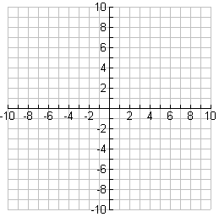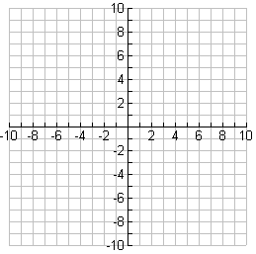

# Definitions

# A graph increasing from zero two to six five. there are holes at two three and three four, with an isolated point at two five A graph increasing from zero two to six five. there is a hole at two three, with an isolated point at two five. the hole at three four from the previous picture has been filled with a closed dot

# Limits:

There is a technical definition, but for us, the intuitive definition will do just fine. Here it is:

The limit $L$ is the value the function “gets close to” if we make the *x* values “get close to” (but not equal to) $a$*.* We write $\lim_{x →a}{f\left(x\right)=L}$.

# Continuity:

**Definition:** A function $f\left(x\right)$ is continuous at $x=a$ if and only if $\lim_{x→a}f\left(x\right)=f\left(a\right)$.

This definition actually states three things:

1.

2.

3.

# Part 1: Limits and Continuity given by a Graph

Let $y=f\left(x\right)$ be given by the graph below. Use the graph to find the following.

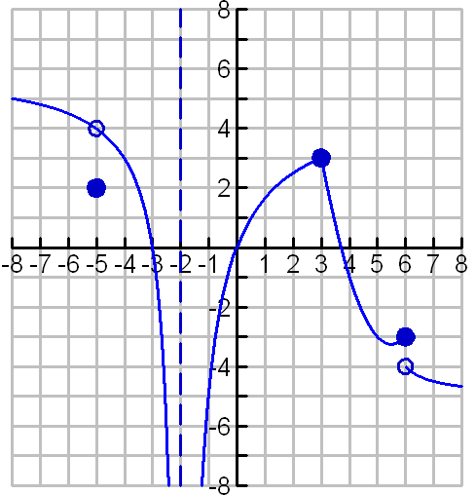

1. a. $f\left(1\right)=$

b. $\lim_{x→1}{f}\left(x\right)=$

c. Is $f$ continuous at $x=1$?

d. $\lim_{x→1}\left(f\left(x\right)+3x\right)=$

1. a. $\lim_{x→-2^{-}}{f}\left(x\right)=$

b. $\lim_{x→-2^{+}}f\left(x\right)=$

c. $\lim_{x→-2}{f}\left(x\right)=$

d. Is $f$ continuous at $x=-2$?

1. a. $\lim_{x→-5^{-}}{f}\left(x\right)=$

b. $\lim_{x→-5^{+}}{f}\left(x\right)=$

c. $\lim_{x→-5}{f}\left(x\right)=$

d. $f\left(-5\right)=$

e. Is $f$ continuous at $x=-5$?

f. $\lim_{x→-5}\left(4f\left(x\right)\right)=$

1. a. $\lim_{x→3^{-}}{f}\left(x\right)=$

b. $\lim_{x→3^{+}}{f}\left(x\right)=$

c. $\lim_{x→3}f\left(x\right)=$

d. $f\left(3\right)=$

e. Is $f$ continuous at $x=3$?

f. $\lim_{x→3}{\sin\left(\frac{π}{3}f\left(x\right)\right)=}$

1. a. $\lim_{x→6^{-}}f\left(x\right)=$

b. $\lim_{x→6^{+}}f\left(x\right)=$

c. $\lim_{x→6}f\left(x\right)=$

d. $f\left(6\right)=$

e. Is $f$ continuous at $x=6$?

f. $\lim_{x→∞}f\left(x\right)=$

g. $\lim_{x→-∞}f\left(x\right)=$

# Part 2: Limits and Continuity given by an Equation

**Hints about finding Limits:**

* Plugging in nearby numbers will get you no credit unless the directions specifically say to do so.
* For any function which is CONTINUOUS, you can find the limit just by plugging in the number as long as the answer is defined.
  + In particular we know the following functions and all their combinations are continuous wherever they are defined:

____________________________ ____________________________

____________________________ ____________________________

____________________________ ____________________________

____________________________

* Ways you can combine continuous functions to get another continuous function:

____________________________ ____________________________

____________________________ ____________________________

____________________________ ____________________________

* What do you do if the function is undefined? Look at the form of the limit!

$\frac{\text{zero}}{\text{nonzero} \text{number}}$ $\frac{\text{nonzero} \text{number}}{\text{zero}}$ $\frac{\text{zero}}{\text{zero}}$

$\frac{\text{number}}{\text{infinity}}$ $\frac{\text{infinity}}{\text{infinity}}$

# Limits Problems:

$f\left(x\right)=\frac{1}{x-1}$

$\lim_{x→1^{-}}f\left(x\right)=$

$\lim_{x→1^{+}}f\left(x\right)=$

$\lim_{x→1}f\left(x\right)=$

$\lim_{x→∞}f\left(x\right)=$

1. List the asymptotes of $f$. Justify your answers by citing appropriate limits. Explain how you know there are no others.
$f\left(x\right)=\frac{x^{2}-1}{x+1}$

$\lim_{x→-1^{-}}f\left(x\right)=$

$\lim_{x→-1^{+}}f\left(x\right)=$

$\lim_{x→-1}f\left(x\right)=$

$\lim_{x→∞}f\left(x\right)=$

$h\left(x\right)=\frac{x^{2}-3x-4}{2x^{2}-4x-6}=\frac{\left(x-4\right)\left(x+1\right)}{2\left(x+1\right)\left(x-3\right)}$

$\lim_{x→-1}h\left(x\right)=$

$\lim_{x→3}h\left(x\right)=$

$\lim_{x→4}h\left(x\right)=$

$\lim_{x→∞}h\left(x\right)=$

2. List the asymptotes of $h$. Justify your answers by citing appropriate limits. Explain how you know there are no others.

$h\left(x\right)=\left\{\begin{matrix}-x^{2}+9, & x≤-2 \\ -2x+1, & -2<x<2 \\ x+1 & x≥2\end{matrix}\right\}$

$\lim_{x→-2}h\left(x\right)=$

$\lim_{x→2} h\left(x\right)=$

$\lim_{x→1} h\left(x\right)=$

$\lim_{x→0}\frac{x}{\sqrt{x+1}-1}$

# Comparison of Limits vs. Continuity

## Limits

### Conceptually

Where is the function headed (y-value) as you get near a certain x-value?

### Graphically

No jumps or infinite squiggles, ignore the point itself

### Algebraically

Limits from both sides have to agree

### Math Notation

$$\lim_{x→a^{+}}{f}\left(x\right)=\lim_{x→a^{-}}{f}\left(x\right)$$

$f\left(x\right)$ is defined on an interval on both sides of $a$

## Continuity

### Conceptually

Can you draw it without picking up your pencil?

### Graphically

No holes, breaks or infinite squiggles

### Algebraically

1. Limits from both sides have to agree
2. The y-value of the point has to agree with the limit

### Math Notation

$\lim_{x→a^{+}}{f}\left(x\right)=\lim_{x→a^{-}}{f}\left(x\right)$

1. $f\left(a\right)$ is defined

$f\left(a\right)=\lim_{x→a}f\left(x\right)$

# Squeeze Theorem

Let $f(x)= \sin\left(x\right)$. Evaluate the limit:

$$\lim_{x→∞}{\frac{f\left(x+1\right)}{2x^{2}}}$$

# Intermediate Value Theorem

If $f$ is a continuous function on the closed interval $[a, b]$, and $d$ is any value between $f(a)$ and $f(b)$, then there is a number $c$ in $(a, b)$ such that $f(c) = d$.

We will use the IVT to show that the equation

$$2\log\left(x\right)=\frac{1}{π}$$

has a solution on the interval (1, 10).

1. IVT requires a single function, $f$. What is your choice for $f\left(x\right)$? ___________________________
2. **On which interval** do we need to show that $f$ is continuous? _____________________________
3. Explain why $f$ is continuous on that interval.
4. Evaluate $f\left(1\right)$ and $f\left(10\right)$. $f\left(1\right)=$
$$f\left(10\right)=$$

5. IVT requires a number, $d$. What is your choice for $d$? $d=$
6. Fill in the blanks appropriately (according to your answers above): $f\left( \right)<d<f\left( \right)$
7. Based on your answers above, explain how to use IVT to determine that the equation has a solution in the interval (1, 10).